**Mission 8:**

**Answer Bot**

**Student Workbook**





**Let’s get random**

In the last mission, the person running the program had control over what happened. In real-life, sometimes values need to be random.

Go to the Mission 8 Log and fill out the Pre-Mission preparation.

* What are some examples of when you might need something random?

**Mission 8: Answer Bot**

**In this project you will create a random answer generator.**

* Instead of selecting messages yourself, like in the previous project, you will have the computer decide for you!

→ Just press a button and let your **Answer Bot** decide :-)

**Mission 8: Get started**

* Go to <https://make.firialabs.com/> and log in.



* Go to Mission 8



* Click and start Mission 8.

**Objective #1: Display a number**

Review displaying an integer from Mission 4

* Start this project by writing code that will:
  + Assign a variable an integer value
  + Display the variable

**DO THIS:**

* Start a new file named   
  **Answer_Bot**
* Import the codex module
* Assign **number** the value 1
* Use **display.show()** with number
  + Use CodeTrek if you need help
* This will cause an error – do you recognize the error before you run the code? 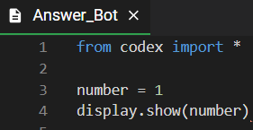

**Objective #2: Fix it up**

In Mission 4, you learned two ways to fix the error:

* Convert (change) the integer to a string
  + str(number)
* Use display.print(number)
  + Automatically converts the integer to a string

**Objective #2: Select more images**

**DO THIS:**

* Change **display.show(number)** to **display.print(number)**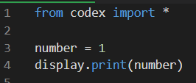

**Objective #3: Randomize!**

Python has a **random** module that has built-in functions

* Import the **random** module to access the functions
* One of the built-in functions is **randrange**
* The function call looks like this:
  + **random.randrange(end_value)**
* The **randrange** function returns a random integer between 0 and one less than the end value
* Examples:
  + **number = random.randrange(10)**
  + Gives a random number from 0 to 9
  + **number = random.randrange(5)**
  + Gives a random number from 0 to 4

The **randrange** function generating a random integer between 0 and one less than the end value is really handy!

* The **list index** starts at 0 and goes to one less than the number of items
* If you have a list with 6 items, you can get a random index by using
* Or, use the len() function and avoid the magic number:



**Objective #3: Randomize!**

One more thing: You can make your print bigger!

* **display.print()** has an argument for scale

**display.print(number, scale=1)**

* scale=1 is the normal size
* scale=2 makes the text bigger
* scale=3 makes the text even bigger
* If you make the scale too big, the text won’t fit on the screen
* Instead it will look like weird shapes
  + If this happens, you know the scale is too big

**Objective #3: Randomize!**

**DO THIS:**

* Change the value of **number** to a   
  random number between 0 and 9
* Add a scale argument to the   
  display.print() statement: start with **scale=1**
* Run the code, then change the scale: **scale=3**
* Run the code, then change the scale to a different number
* Run the code several times. You should get a different random number each time.
* NOTE: *Sometimes you may see the same number repeat, but that's all part of the randomness!*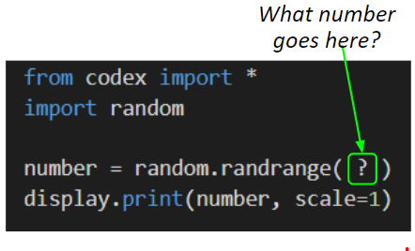

**Objective #4: Mix things up**

* You can improve the code by using a CodeX button   
  and a loop.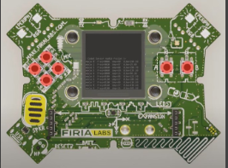

**DO THIS:**

* Go to your Mission Log and write down   
  what you remember about CodeX buttons and loops

**Objective #4: Mix things up**

Running the program every time you want a random number isn’t very fun.

Modify your code to:

* Use a loop
* Get a random number every time BTN_A is pressed



**Modify your code**

**DO THIS:**

* Add a **while True:** loop
* Add code to check for a button press (BTN_A)
* Run the code and press BTN_A several times
* 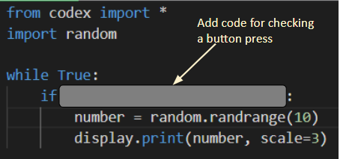You should see a random number each time you press the button

**Objective #5: Robot opinion**

Now that you can display a random number, can you display a random text from a list?

* Time to give CodeX an opinion!
* Think of a question you want CodeX to answer
* Then display a random answer
* This is a perfect place for a list
* Use a random number for the index

This is your Answer Bot, so you can choose the question you want it to answer

* It could be
  + Favorite sports team
  + Best singer / band
  + Favorite food
  + Magic 8 Ball answers
  + Best subject in school
  + ***You*** decide!

**Objective #5: Robot opinion**

**DO THIS:**

* Go to the Mission Log and plan your question and several possible answers
* Modify the code by creating   
  a list in your code with the possible answers
* Assign a variable the number of items   
  (len of list)

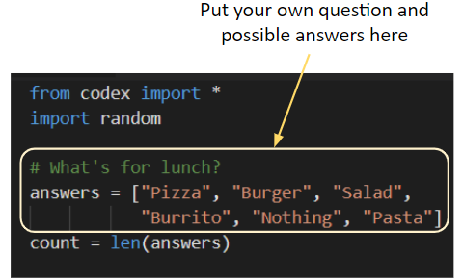

* Modify the if statement to:
  + Get a random number for the index
  + Assign a variable the value from the list
  + 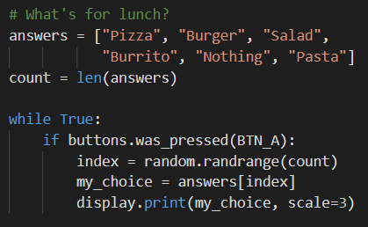Display the list item variable (adjust the scale if needed)

 **Mission Quiz: Get some answers**

Test your skills by **taking the quiz**.

**Objective #6: Wait for answer**

* 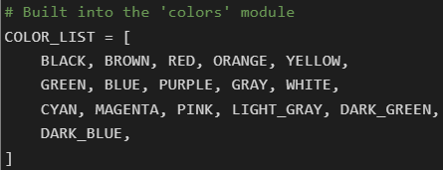The CodeX module has a built-in list for colors - no need to create one.

* You do not need to type this in your code
* You can use this list to select a random color for the pixels.
* Let the pixels cycle through random colors while you wait for an answer!

Working with the built-in COLOR_LIST:

* **len(COLOR_LIST)** will give you the number of items
* Use **len(COLOR_LIST)** to get a random number
* 
* Use the random number to get a color from the list
* 
* 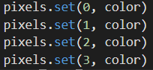Use the color to turn on the pixels

**Objective #6: Wait for answer**

Put it all together!

**DO THIS:**

* Import sleep
* Get a number for a random pixel color
* Use the number to get a color from the COLOR_LIST
* Use the color to turn on all the pixels
* Use a short sleep to make the pixels flash

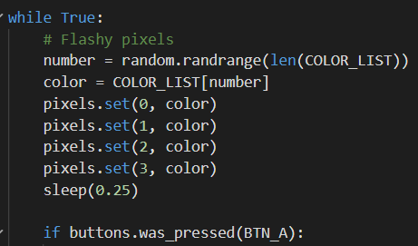

**Objective #7: Choices, choices**

Four flashing pixels is … flashy!

* What about making the four pixels flash different colors instead of the same color?
* You just have to assign a random color to each pixel
* This could take a few lines of code, so…
* There is a simpler way

Another built-in random function

* You already know about **random.randrange()**
* Another built-in function is **random.choice()**
* It will randomly pick an item from a list – No need to use a number or index variable
* It looks like this: 

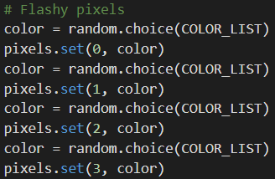You can use this command, one for each pixel:

  
  
Do you think you can use **random.choice()** for your **answers** list as well?

**Objective #7: Choices, choices**

**DO THIS:**

* Delete the two lines of code that use **random.randrange()**
  + One for color
  + One for answers
* Delete the **count** variable (not needed anymore)
* Modify the code for **color** and **my_choice** to use **random.choice()**
* Get four random colors and use each one in a different pixel
* Use the code snippets on the previous page if you need help

**Objective #7: Choices, choices**

**DO THIS:**

* Does your code look similar to this?
* Did you pass off your two goals?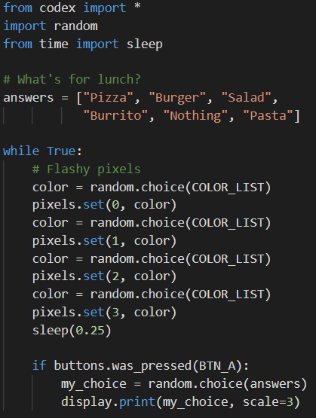

**Mission Complete**

You have completed the eighth mission. 

**Do this:**

* Read your “Completed Mission” message
* Complete your Mission 8 Log
  + Post-Mission Reflection
* Get ready for your next mission!

**Wait! Before you go … Clear the CodeX**

Go to FILE -- BROWSE FILES

Select the “**Clear**” file and open it

Run the program to clear the CodeX

**Okay. Now you can go.**